Test # 309
Instrument Name Consistometer
Instrument Type Consistometer
Test Start 15/05/01 10:33
Test Stop 2:08:06
Well ID # KHVALYNSKAYA #3
Customer LUKOIL
Cement Class G
Additives 0.15%THR-100+30%SF+Defoamer
Cement Mfr DYKERHOFF
BHCT 105
BHST 128
Density 1900
Fluid Loss 110cc/30min
Job Type 194 MM CSG

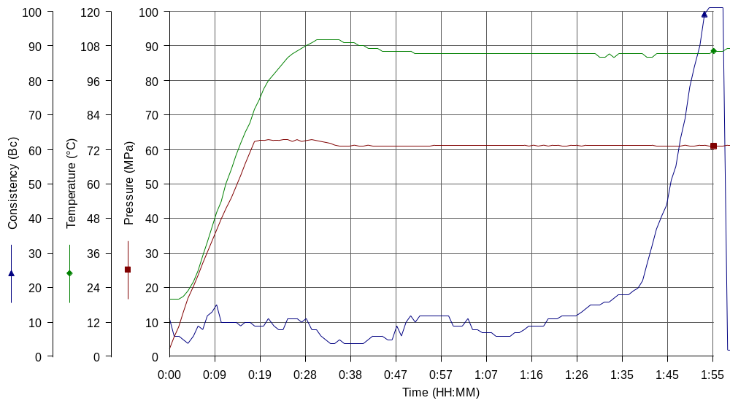
Comments MPa: 60.9(18min); T: 90C(18min); 105(10min); Tap water, Dry blend ASTRA cem+30%SF; premix THR-100, Spread-ty: 25 cm

